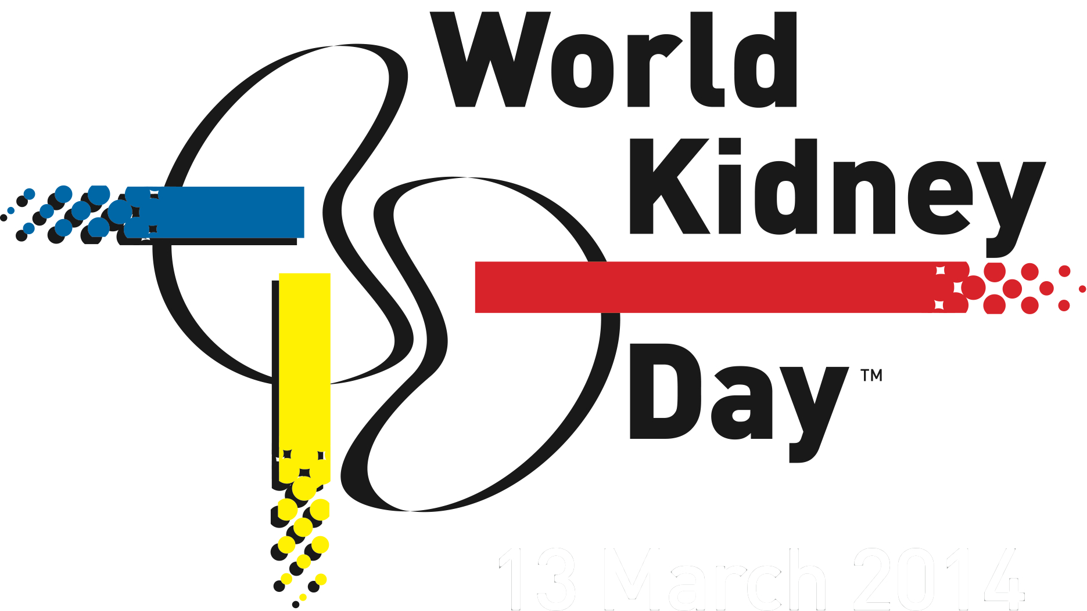

**PRESS RELEASE**

**EMBARGO**

**Kidney Disease & Children - Act early to prevent it.  
Support WKD by moving your feet!**

*Brussels, February 22, 2016* – 10% of the population worldwide is impacted by some form of kidney damage.

**On Thursday March 10th we are celebrating the 11th edition of World Kidney Day (WKD), a joint initiative organized by the International Society of Nephrology (ISN) and the International Federation of Kidney Foundations (IFKF). WKD is the most widely celebrated event focused on kidney health across the globe. This year’s theme “Kidney Disease and Children” reminds us that we must all think about our kidneys from an early age and that much adult renal disease is actually initiated in childhood.**

With 10% of the population worldwide having some form of kidney damage, there is a long road ahead to raise awareness about the dangers of kidney disease. The latest numbers show that Chronic Kidney Disease (CKD) is predicted to increase by 17% over the next decade and is now recognized by WHO and other organizations as a global public health issue.

Kidney diseases affect millions of people worldwide, including many children. Some children are born with kidney disease and others develop it when still very young. The symptoms of kidney disease in children are often nonspecific, which means that there is a risk that kidney problems may be missed in children. In childhood the leading causes of kidney failure in children are hereditary conditions, often lacking obvious indicators such as hematuria (red blood cells in the urine), hypertension (high blood pressure) or edema (swelling). Additionally, kidney disease that becomes evident in adulthood may occur more often in persons with risk factors that can be detected in childhood.

It is therefore crucial that we encourage and facilitate education, early detection and a healthy life style in children, starting at birth and continuing through to old age, to combat the increase of preventable kidney damage including Acute Kidney Injury (AKI) and CKD and to treat children with inborn and acquired disorders of the kidney

Julie Ingelfinger, MD, Professor of Pediatrics at Harvard Medical School and Senior Consultant in Pediatric Nephrology at MassGeneral Hospital for Children, underlines the importance of CKD awareness and prevention from early age on: *“It is important to be aware of and to detect pediatric kidney disease. Kidney disease can be treated, even in our smallest patients. Further, because much of adult kidney disease has its roots in childhood, it is critical to focus on infancy and childhood if we are to prevent and cure kidney diseases.“*

***On World Kidney Day, move your feet!*** – Keeping fit reduces high blood pressure and obesity, two of the leading causes of kidney disease.

This is why, leading up to **March 10** and beyond, **we encourage** **civil society, decision-makers, health ministries and professionals as well as patients to move their feet for healthy kidneys**. This gesture is a vivid reminder that regular exercise and physical activity help to reduce the risk of developing kidney disease. Moving our feet is a simple yet powerful action that creates a link between our health and our daily routine.

***Show your support online globally*** – Building on the great success of our WKD campaigns over the last years, which included over 560 reported events taking place in more than 90 countries and 50 million people talking about WKD through the campaign hashtag #worldkidneyday in 2015, we call on our community to share their activities, messages and pictures online and get involved in the fight against kidney disease. For more information and details about World Kidney Day events worldwide – please see [www.worldkidneyday.org](http://www.worldkidneyday.org)

Participants can send us messages and their pictures, using **#moveyourfeet4WKD**.

Our campaign can be followed online on: [C:\Users\Sophie\Dropbox\WKD\2014\Graphics\Social Media visuals\Social media icons website\facebook_logo.png](https://www.facebook.com/worldkidneydayofficial) [C:\Users\Sophie\Dropbox\WKD\2014\Graphics\Social Media visuals\Social media icons website\twitter_logo.png](https://twitter.com/worldkidneyday) [C:\Users\Sophie\Dropbox\WKD\2014\Graphics\Social Media visuals\Social media icons website\googleplus_logo.png](https://plus.google.com/u/0/117842957806163318518/posts) [C:\Users\Sophie\Dropbox\WKD\2014\Graphics\Social Media visuals\Social media icons website\youtube_logo.png](http://www.youtube.com/user/TheWorldKidneyDay?feature=watch)

***About the organizers of World Kidney Day:***

World Kidney Day is a joint initiative of the International Society of Nephrology (ISN) and the International Federation of Kidney Foundations (IFKF).

Founded in 1960, the International Society of Nephrology (ISN) is a global not-for-profit society dedicated to improving kidney care and reducing the incidence and impact of kidney disease worldwide. Through its global network and programs, ISN brings together the developing and developed world in a collaborative effort in fighting and treating kidney disease on a global scale.

More information on [www.theisn.org](file:///C:\Users\Sophie\AppData\Local\Microsoft\Windows\INetCache\Content.Outlook\RXPCH3DQ\www.theisn.org).

The International Federation of Kidney Foundations (IFKF), a not-for-profit Federation founded in 1999, currently has a membership of 63 kidney founations and patient groups in 41 countries. IFKF advocates worldwide to improve the health, well-being and quality of life of individuals with kidney disease; disseminates standards of best practice of treatment and care; assists with the establishment of kidney foundations in countries where they do not yet exist; facilitates educational programs for it members; and promotes kidney disease research.

More information on [www.ifkf.org](http://www.ifkf.org).

***World Kidney Day Official Partners***

World Kidney Day is grateful to the generous support of its global corporate contributors who help us make this day of global action possible. Thanks very much to:

* Our WKD Partners:





* Our WKD Supporters:



* Our WKD Benefactors: Alexion, Baxter, Fresenius Medical Care, and Intuitive Surgical

***Press contacts:***

**Agnese Ruggiero Tina Bielawska**

World Kidney Day Campaign Coordinator PR Director, Ogilvy Public Relations

Email: [agnese@worldkidneyday.org](mailto:agnese@worldkidneyday.org) Email : [tina.bielawska@ogilvy.com](mailto:tina.bielawska@ogilvy.com)

Phone : +32 2 808 04 20 Mobile : +32-477-938256